**CRM in Banking**

**Customer Relationship Management (CRM):** A business strategy that focuses on improving customer relationships and fostering customer loyalty. A CRM system is a software solution designed to support this strategy by centralizing customer data from various sources (branches, online banking, mobile app).

**Functionalities and Value of a CRM System:**

* **Customer 360:** A holistic view of each customer, encompassing their financial profile, preferences, and banking history, consolidated from all touchpoints (branch visits, online transactions, mobile app interactions, and even social media sentiment).
* **Personalized Service:** Enables branch staff to anticipate customer needs and recommend tailored financial solutions, fostering trust and strengthening relationships.
* **Targeted Sales & Marketing:** Identifies upselling and cross-selling opportunities by analysing customer data and transaction patterns.
* **Enhanced Customer Satisfaction:** Streamlines workflows and ensures efficient issue resolution, leading to reduced frustration and a demonstration of the bank's commitment to exceptional service.
* **Data-Driven Decision Making:** Provides a goldmine of data for strategic decision-making. By analysing customer behaviour and preferences, banks can identify trends, inform product development, and tailor marketing campaigns.
* 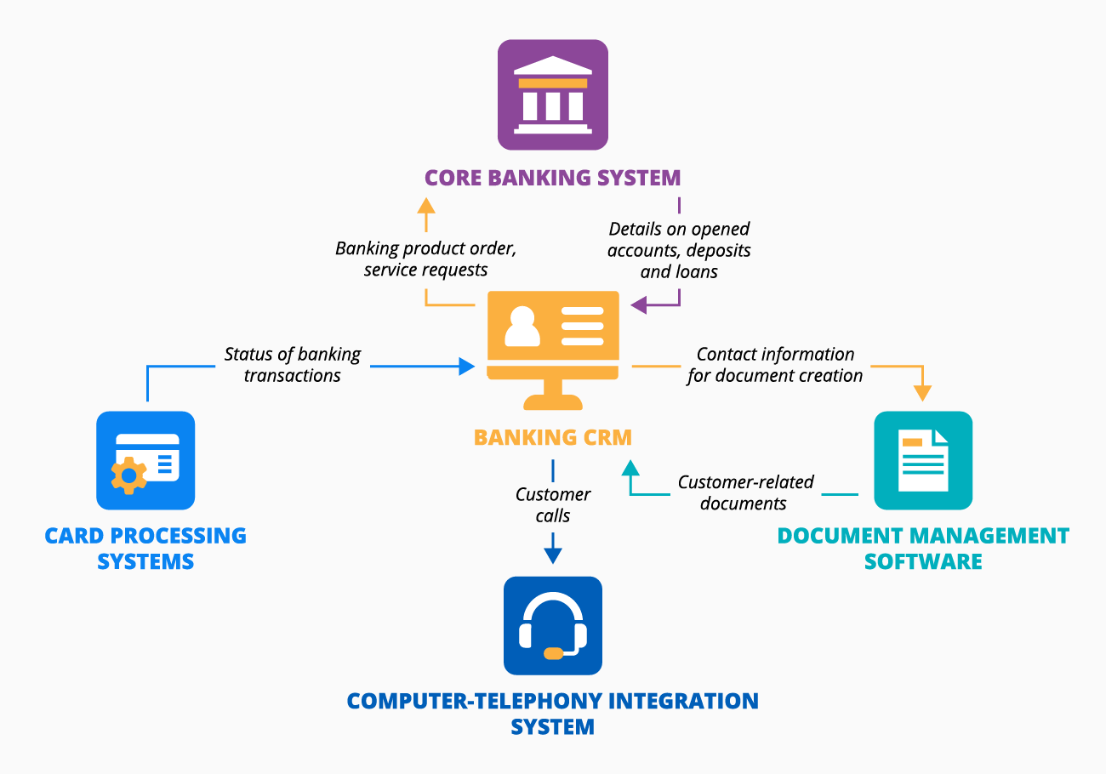

**Branch Network Management**

**Branch Network Management:** The process of strategically managing the geographical distribution and operations of a bank's physical branches.

**Key Considerations in Branch Network Management:**

* **Customer Centric Location Strategy:** Data analysis helps identify areas with high customer concentration and preferred service options (in-person vs. digital banking). This informs branch location decisions and service tailoring.
* **Performance Analysis & Resource Allocation:** Analyses branch performance metrics (transaction volume, account openings, profitability) to identify areas for improvement, optimize staffing levels, and ensure efficient resource allocation.
* **Cost Optimization:** Evaluates the need for new branches, potential closures, or consolidations based on data-driven insights to maintain a cost-effective network that caters to customer needs.
* **Omnichannel Experience:** Ensures a seamless transition between physical branches and digital banking options, providing consistency across all channels.

**The CRM & Branch Network Management Symphony**

CRM and branch network management are not isolated entities; they work in tandem to create a powerful synergy:

* **CRM Informs Branch Network Decisions:** Customer interaction data from the CRM can inform branch staffing decisions. For instance, data revealing a high volume of complex transactions at a particular branch would necessitate staff with specialized financial knowledge.
* **Branch Data Enhances CRM:** Branch performance data fed back into the CRM provides insights into customer behavior by location. Imagine identifying a surge in demand for wealth management services at a specific branch. The CRM can be used to target marketing campaigns for wealth management products to customers in that area.

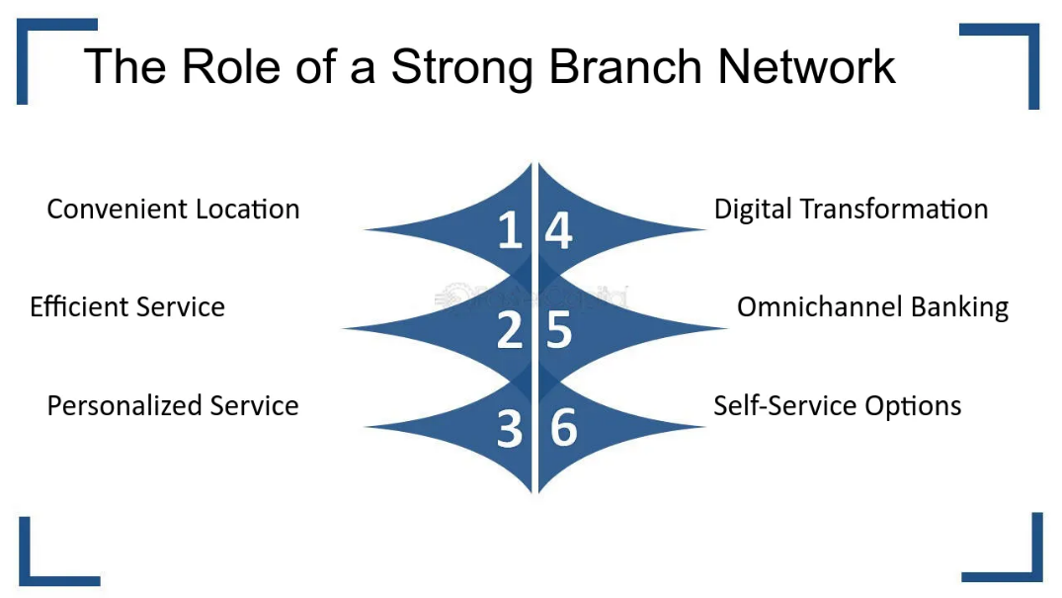

**Checking accounts and Savings accounts**

The Role of Banks in the Business World

Banks are financial institutions that act as intermediaries between businesses, individuals, and other entities, facilitating financial transactions. They offer a variety of services essential for business operations, including:

* **Cash Management:** The process of managing a business's incoming and outgoing cash flow. Checking accounts provide a secure method for depositing and withdrawing funds.
* **Payment Processing:** The act of electronically transferring funds to complete a financial transaction. Businesses utilize various methods like checks, ACH (Automated Clearing House) payments, and wire transfers to pay vendors and employees. Banks handle the secure and efficient processing of these transactions.
* **Loans and Lines of Credit:** Debt financing provided by banks to businesses. Loans are a lump sum of money borrowed for a specific period with interest, while lines of credit offer access to funds up to a certain limit as needed. Businesses rely on them for financing operations, expansion projects, and short-term needs.
* **Merchant Services:** Specialized banking services that allow businesses to accept credit card and debit card payments from customers. These services typically involve processing transactions, managing authorization, and settling funds.

**Checking Accounts: The Workhorse of Business Finances**

* **Types of Checking Accounts:**
  + **Business Checking Account:** A deposit account designed for day-to-day business transactions. It typically offers features like multiple authorized users for check signing and debit card access, allowing for easier management of company finances.
  + **Money Market Checking Account:** A hybrid account that combines features of checking and savings accounts. It allows for limited check writing while offering a slightly higher interest rate on the account balance compared to traditional checking accounts.
  + **Interest-Bearing Checking Account:** A checking account that earns minimal interest on the account balance while still allowing for easy access to funds through debit cards, checks, and online banking.
* **Reconciliation:** The process of comparing a business's bank account statement with its internal financial records to ensure all transactions are accurate and accounted for. Discrepancies are identified and resolved during this process.
* **Positive Pay:** A service offered by some banks to help prevent fraudulent checks. The business provides the bank with a list of authorized checks beforehand. The bank then verifies the legitimacy of each check presented for payment, helping to prevent fraudulent transactions.
* **Cash Flow Management:** Business analysts can leverage checking account data to analyse patterns in a company's cash flow. This analysis helps identify areas for improvement in managing incoming and outgoing funds and allows for forecasting future financial needs.

**Savings Accounts: Building a Financial Buffer**

* **High-Yield Savings Accounts (HYSAs):** Savings accounts that offer a higher interest rate than traditional savings accounts. These are ideal for parking emergency funds or saving for short-term goals where the money needs to be readily accessible.
* **Certificate of Deposit (CD):** A type of deposit account that offers a fixed interest rate for a predetermined investment period. The funds are locked in for the term, and early withdrawal typically results in a penalty. CDs are suitable for saving for long-term goals where the money won't be needed immediately.
* **Sweep Accounts:** A combination savings and checking account offered by some banks. Excess funds from a checking account are automatically transferred to a linked savings account, maximizing the interest earned on idle funds. Sweep accounts can help businesses optimize their cash management.
* **Emergency Funds:** A readily available pool of money set aside to cover unexpected expenses or disruptions in cash flow. Businesses should maintain a healthy emergency fund in a savings account to ensure financial stability during unforeseen circumstances.
* 